# JS Advanced: Exam 23 July 2017

Problems for exam preparation for the [“JavaScript Advanced” course @ SoftUni](https://softuni.bg/courses/javascript-advanced). Submit your solutions in the SoftUni judge system at <https://judge.softuni.bg/Contests/699/>.

# Problem 1. Select and Print (Simple DOM Interaction)

You are given the following **HTML code**:

|  |
| --- |
| select-print.html |
| <!DOCTYPE **html**> <**html**> <**head**>  <**title**>Select and Print</**title**>  <**style**>  **select** { **width**: 100**px** }  .**block** { **display**: **inline-block**; **vertical-align**: **top**; **text-align**: **center** }  **button** { **width**: 60**px** }  **#btnRight** { **display**: **block**; **margin-top**: 20**px** }  **#btnLeft** { **display**: **block**; **margin-top**: 5**px** }  **#btnPrint** { **display**: **block**; **margin-top**: 5**px** }  </**style**>  <**script src="https://code.jquery.com/jquery-3.1.1.min.js"**></**script**> </**head**> <**body**> <**div class="block"**>  <**div**>Available towns</**div**>  <**select id="available-towns" size="5"**>  <**option**>Sofia</**option**>  <**option**>Varna</**option**>  <**option**>Pleven</**option**>  </**select**> </**div**> <**div class="block"**>  <**button id="btnRight" onclick="***move*(**'right'**)**"**>**&rightarrow;**</**button**>  <**button id="btnLeft" onclick="***move*(**'left'**)**"**>**&leftarrow;**</**button**>  <**button id="btnPrint" onclick="***move*(**'print'**)**"**>Print</**button**> </**div**> <**div class="block"**>  <**div**>Selected towns</**div**>  <**select id="selected-towns" size="5"**>  <**option**>Plovdiv</**option**>  <**option**>Ruse</**option**>  </**select**> </**div**> <**div id="output"**></**div**> <**script**>  **function** *move*(command) {  *//* ***TODO***  }  </**script**> </**body**> </**html**> |

### Your Task

**Write the missing JavaScript function move()**. When a **button** is **clicked**, the function is called with a string **parameter** (a command):

* Parameter "**right**" is received when the 🡪 button is **clicked** – move the selected **town** from **Available** **towns** to **Selected** **towns**
* Parameter "**left**" is received when the 🡨 button is **clicked** – move the selected **town** from **Selected** **towns** to **Available** **towns**
* Parameter"**print**" – Replace the contents of the **div** element with **ID** "**output**" with a list of thetown names of all towns from **Selected towns**, joined with a **semicolon** and **space** ("; ").

You should **not** attach **event listeners** to the buttons, they have already been **configured** (see the **HTML skeleton**).

### Examples

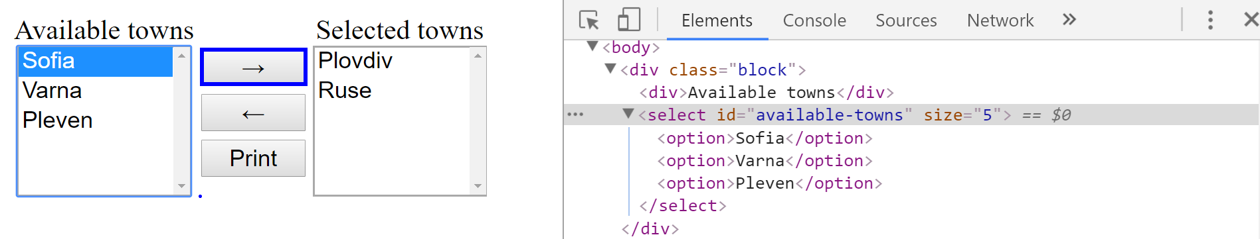

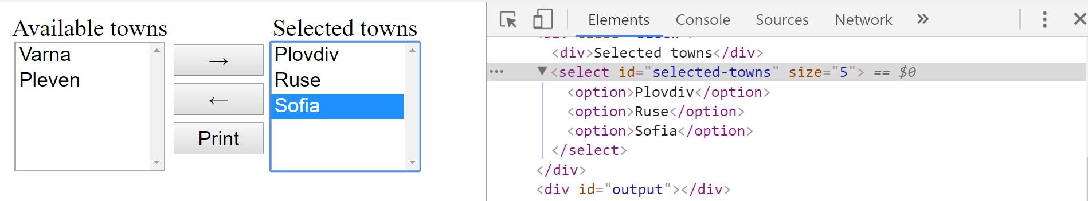

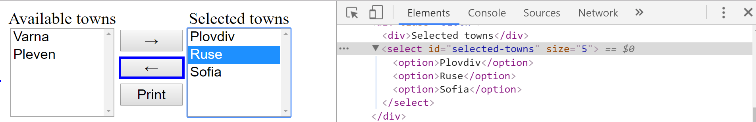

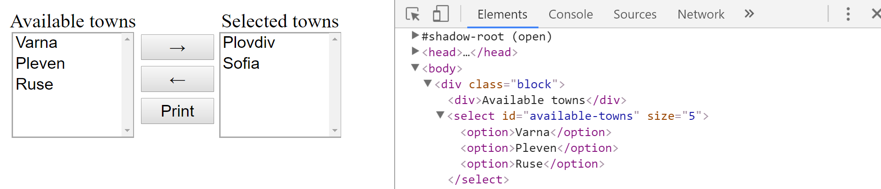

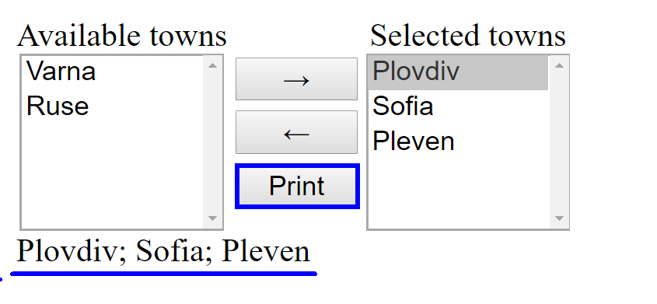

### Submission

Submit only your move function.